Then

Bible Passage: “But God said unto him, Thou fool, this night thy soul shall be required of thee: then whose shall those things be, which thou hast provided? So is he that layeth up treasure for himself, and is not rich toward God.” (Luke 12:20-21)
Introduction:_______________________________________________________________________________________________________________________________________________________________________________________________________________________________________________________________________________________________________________________________________________________________________________________________________________________________________________________________________________________

- His ____________________
  - Success is not ____________________
“And he saw also a certain poor widow casting in thither two mites. And he said, Of a truth I say unto you, that this poor widow hath cast in more than they all: For all these have of their abundance cast in unto the offerings of God: but she of her penury hath cast in all the living that she had.” (Luke 21:2-4)
  - Success is our ____________________ to God
“This book of the law shall not depart out of thy mouth; but thou shalt meditate therein day and night, that thou mayest observe to do according to all that is written therein: for then thou shalt make thy way prosperous, and then thou shalt have good success.” (Joshua 1:8)
“ And said, Naked came I out of my mother's womb, and naked shall I return thither: the LORD gave, and the LORD hath taken away; blessed be the name of the LORD.” (Job 1:21)

- His ____________________
  - The ____________________ of the trade
“And he spake a parable unto them, saying, The ground of a certain rich man brought forth plentifully: And he thought within himself, saying, What shall I do, because I have no room where to bestow my fruits? And he said, This will I do: I will pull down my barns, and build greater; and there will I bestow all my fruits and my goods.” (Luke 12:16-18)
“And Achan answered Joshua, and said, Indeed I have sinned against the LORD God of Israel, and thus and thus have I done: When I saw among the spoils a goodly Babylonish garment, and two hundred shekels of silver, and a wedge of gold of fifty shekels weight, then I coveted them, and took them; and, behold, they are hid in the earth in the midst of my tent, and the silver under it.” (Joshua 7:20-21)
  - The ____________________ of the trade
“And Joshua, and all Israel with him, took Achan the son of Zerah, and the silver, and the garment, and the wedge of gold, and his sons, and his daughters, and his oxen, and his asses, and his sheep, and his tent, and all that he had: and they brought them unto the valley of Achor. And Joshua said, Why hast thou troubled us? the LORD shall trouble thee this day. And all Israel stoned him with stones, and burned them with fire, after they had stoned them with stones.” (Joshua 7:24-25)

- His ____________________
  - The ____________________ of the soul
“And I will say to my soul, Soul, thou hast much goods laid up for many years; take thine ease, eat, drink, and be merry.” (Luke 12:19)

  - The ____________________ of the soul
“So is he that layeth up treasure for himself, and is not rich toward God.” (Luke 12:21)


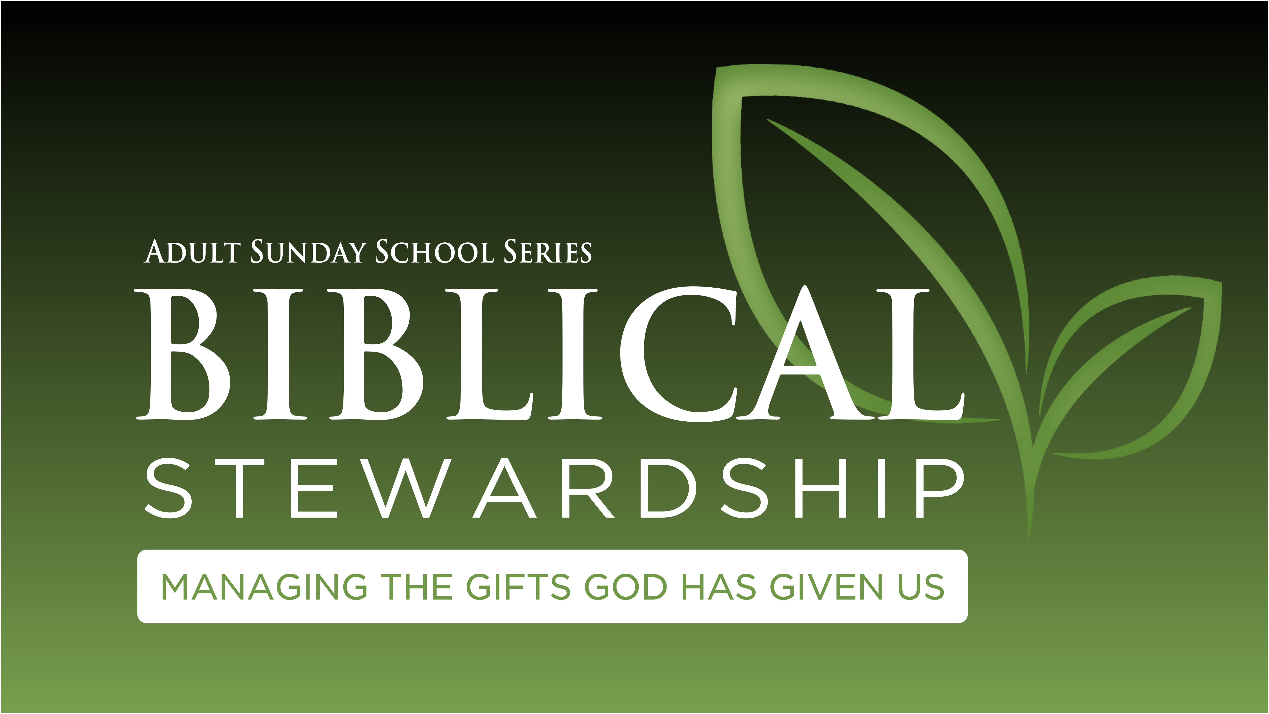
Adult Sunday School
Missionary Spotlight

Update
- Will not be returning to Guyana full-time.
- Transitioning the ministry to new missionary couple.
- Helping Luke Carringer start the Bannerman Baptist Church north of Tallahassee, FL
Prayer Request
- Pray for the transition period that will be complete by the end of July.
- Pray for Bro. Dean’s Health.
- Pray for continued support financially.
The Family

