The Stewardship of Life

Bible Passage: And God said, Let us make man in our image, after our likeness: and let them have dominion over the fish of the sea, and over the fowl of the air, and over the cattle, and over all the earth, and over every creeping thing that creepeth upon the earth. So God created man in his own image, in the image of God created he him; male and female created he them. And God blessed them, and God said unto them, Be fruitful, and multiply, and replenish the earth, and subdue it: and have dominion over the fish of the sea, and over the fowl of the air, and over every living thing that moveth upon the earth. And God said, Behold, I have given you every herb bearing seed, which is upon the face of all the earth, and every tree, in the which is the fruit of a tree yielding seed; to you it shall be for meat. And to every beast of the earth, and to every fowl of the air, and to every thing that creepeth upon the earth, wherein there is life, I have given every green herb for meat: and it was so. And God saw every thing that he had made, and, behold, it was very good. And the evening and the morning were the sixth day. (Genesis 1:26-31)
Introduction: ________________________________________________________________________________________________________________________________________________________________________________________________________________________________________________________________________________________________________________________________________________________________________________________________________________________

- God Has Created Us to Be _______________ with Him
“For we are labourers together with God.” (I Corinthians 3:9)
- Our communication with God
- Our _______________ to God
Quote: God’s original intent in creating man was that man would accomplish what God wants done in this world. -Clarence Sexton
“And unto one he gave five talents, to another two, and to another one; to every man according to his several ability; and straightway took his journey. Then he that had received the five talents went and traded with the same, and made them other five talents. And likewise he that had received two, he also gained other two. But he that had received one went and digged in the earth, and hid his lord's money. After a long time the lord of those servants cometh, and reckoneth with them. And so he that had received five talents came and brought other five talents, saying, Lord, thou deliveredst unto me five talents: behold, I have gained beside them five talents more. His lord said unto him, Well done, thou good and faithful servant: thou hast been faithful over a few things, I will make thee ruler over many things: enter thou into the joy of thy lord.” (Matthew 25:15-21)
“No man liveth unto himself, and no man dieth unto himself.” (Romans 14:7)

- God Has Made Us Stewards Over His ____________________
  - His Ownership
“The earth is the LORD’S and the fullness thereof; the world, and they that dwell therein.” (Psalm 24:1)

  - Our Stewardship
“Teach us to number our days.” (Psalm 90:12)

- God Will Bring It All into ______________________
“And they heard the voice of the LORD God walking in the garden in the cool of the day: and Adam and his wife hid themselves from the presence of the LORD God amongst the trees of the garden. And the LORD God called unto Adam, and said unto him, Where art thou?” (Genesis 3:8-9)

  - __________ Brought To Light
“And he said also unto his disciples, There was a certain rich man, which had a steward; and the same was accused unto him that he had wasted his goods. And he called him, and said unto him, How is it that I hear this of thee? give an account of thy stewardship; for thou mayest be no longer steward.” (Luke 16:1-2)

  - Our _______________ to God
“So then every one of us shall give account of himself to God.” (Romans 14:12)


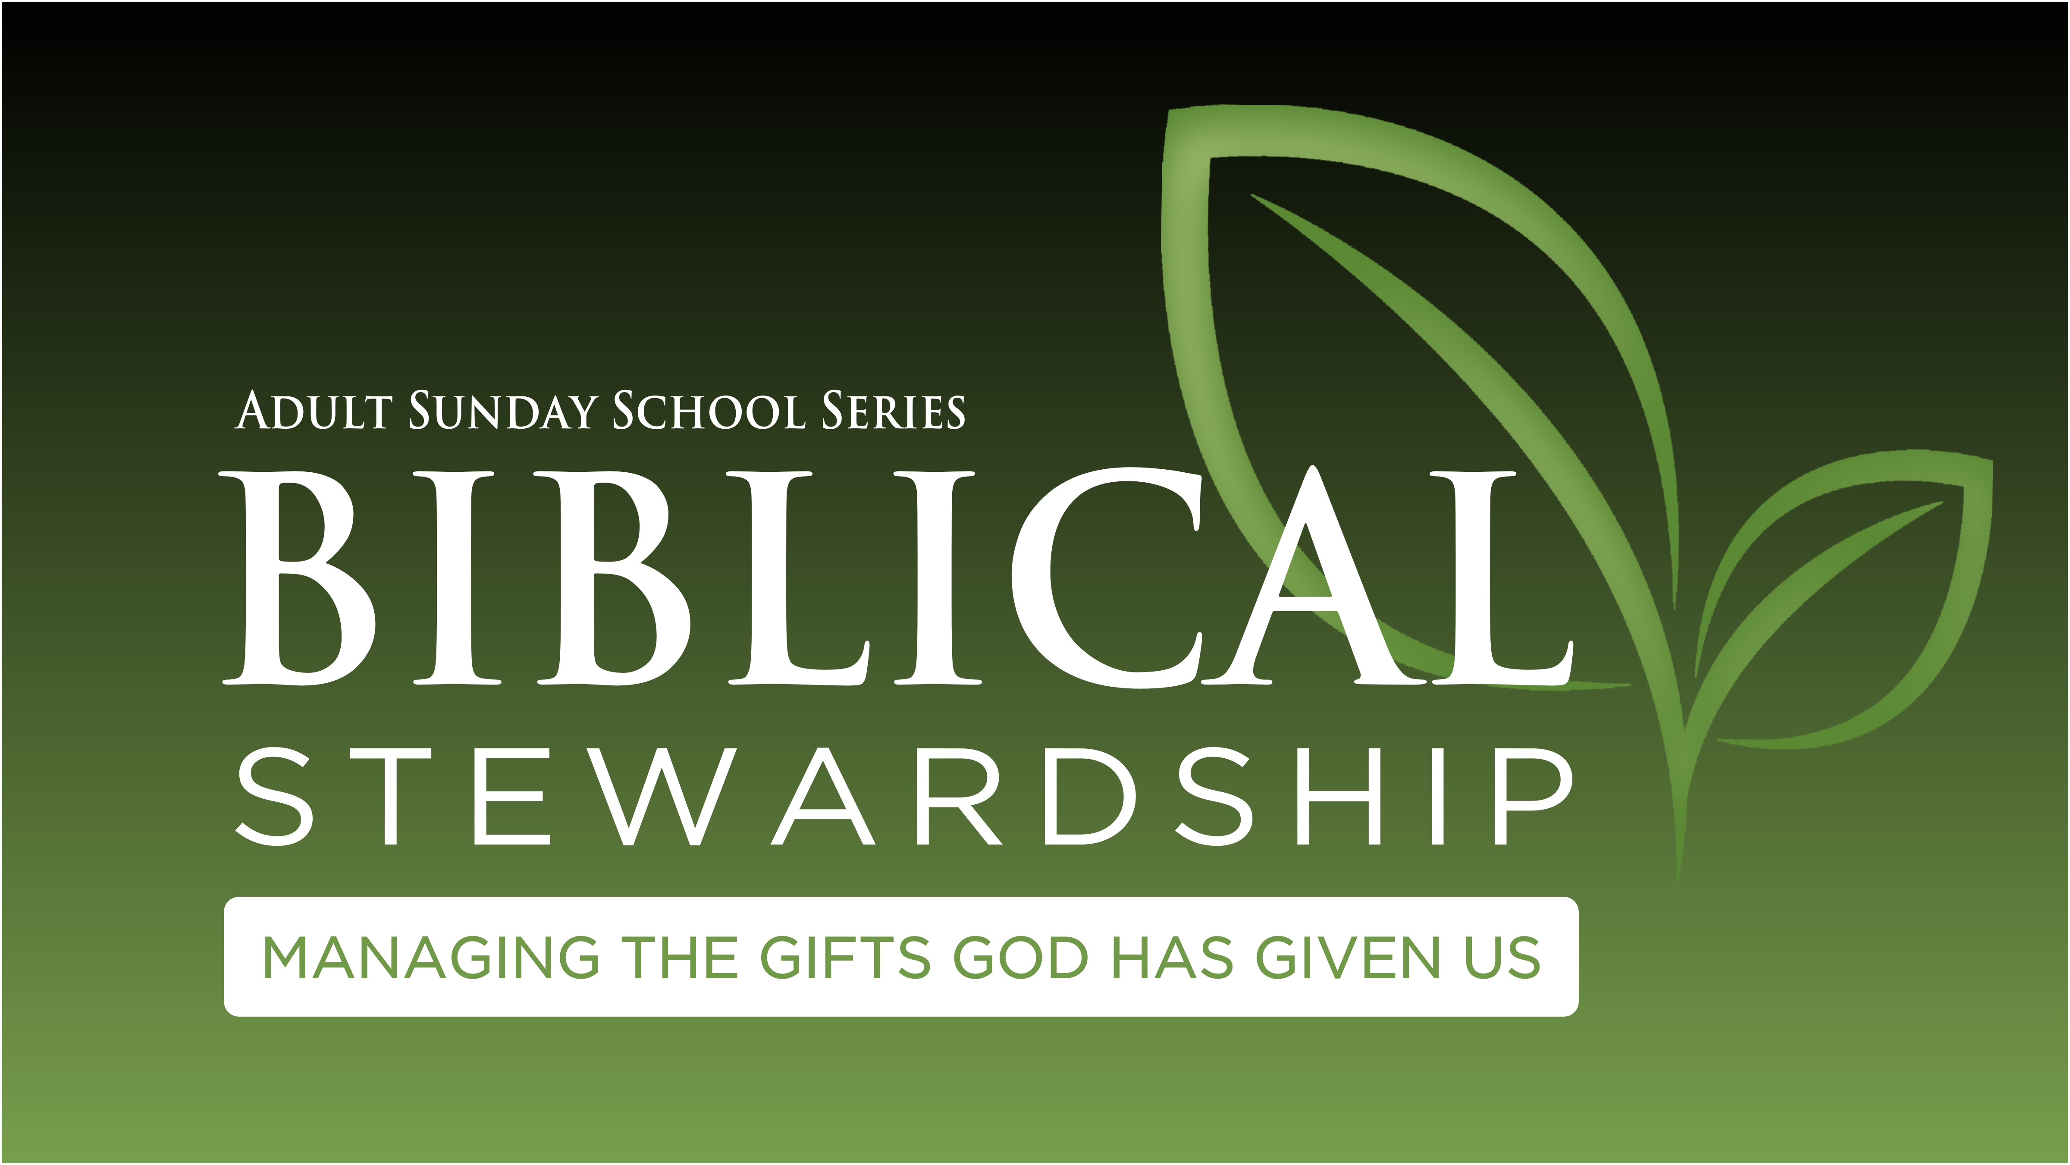
Adult Sunday School
Missionary Spotlight

Update
• Hot water line froze while in Ohio. They were able to get it unfrozen.
• Reached 90% Support
Prayer Request
• Safety while on deputation
• Shipping belongings
• Permanent housing for their arrival in Zambia
The Carr Family

